4 INAs board
Alberto Battistel
24 February 2017

This board contains is made to allocate 4 INAs and 4 variable voltage dividers. INA 1 and 3 have two screw terminals for every inputs. INA 2 and 4 have only one screw terminal for input.

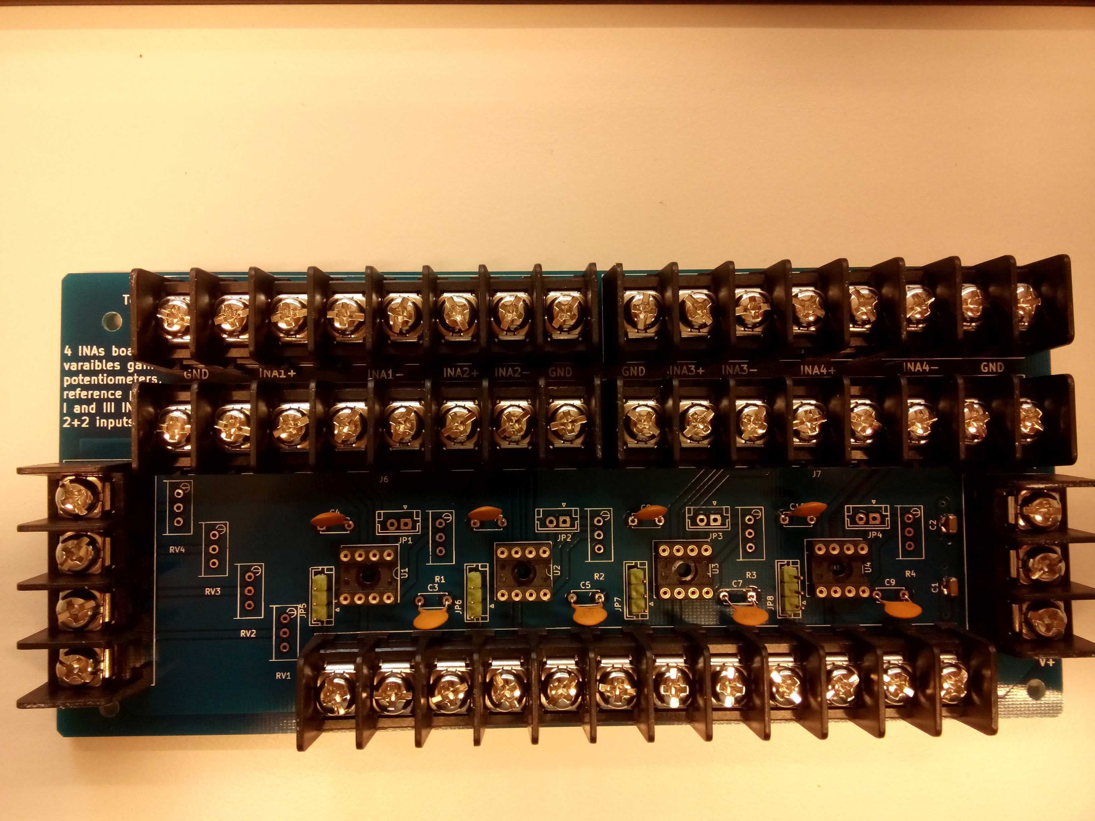
Figure 1: Top view of the board.
Signal inputs
Signaloutputs
Voltage
dividers
Power

Note that there are some errors on the labels of the inputs. The backside (Figure 2) has the right labels.
The double terminal row on the signal inputs can be used for filtering and summing.

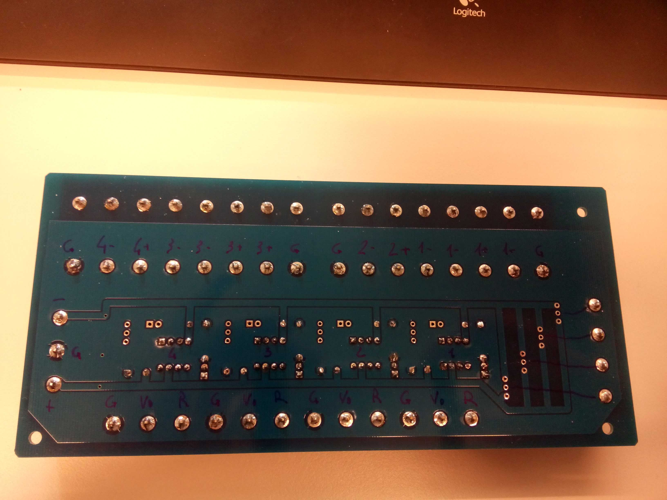
Figure 2: back side of the board with right labels

Label | Description
G | Ground
R | External reference potential
Vo | INA output
+ | Positive rail
− | Negative rail
n+ | Positive input INA n
n− | Negative input INA n
Table 1: labels on the board.

On the board is possible to change the gain factor through a variable resistance and select if the INA works against ground or against a provided reference voltage.
INA
Figure 3: single INA block with jumpers for gain and reference potential.
Variable resistor
for gain
Jumper for gain
Jumper for external
Reference potential
Refer to ground
Refer to external
reference
